EXPERIMENT 1 — IMAGE TO GRAYSCALE
AIM
To read an image using Python and OpenCV and convert the given color image into a grayscale image.
ALGORITHM
- Import the OpenCV library.
- Upload and read the input image.
- Convert the color image into grayscale using cv2.cvtColor().
- Display the original image.
- Display the grayscale image.
- Save the images.
PROGRAM
import cv2
from google.colab import files
from google.colab.patches import cv2_imshow

# Upload image
uploaded = files.upload()

# Read image
filename = list(uploaded.keys())[0]
img = cv2.imread(filename)

# Convert to grayscale
gray = cv2.cvtColor(img, cv2.COLOR_BGR2GRAY)

# Display original image
print("Original Image:")
cv2_imshow(img)

# Display grayscale image
print("Grayscale Image:")
cv2_imshow(gray)
SAMPLE INPUT
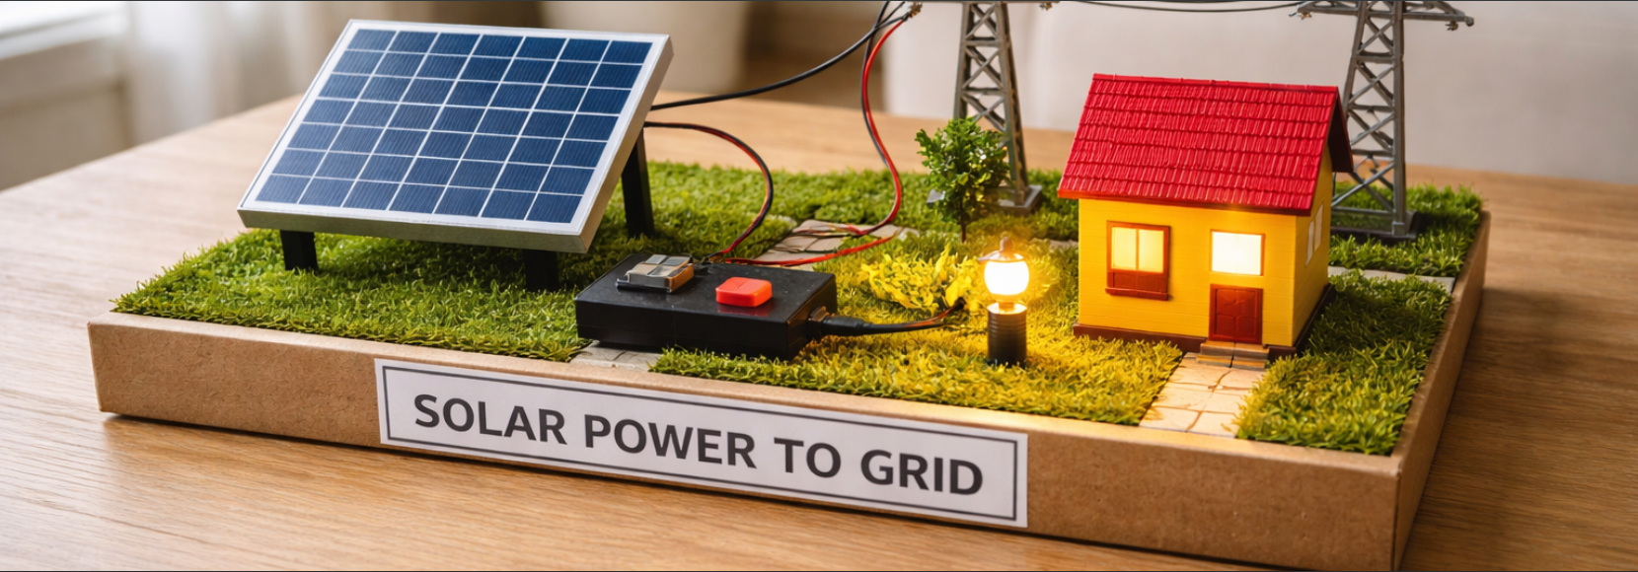
OUTPUT
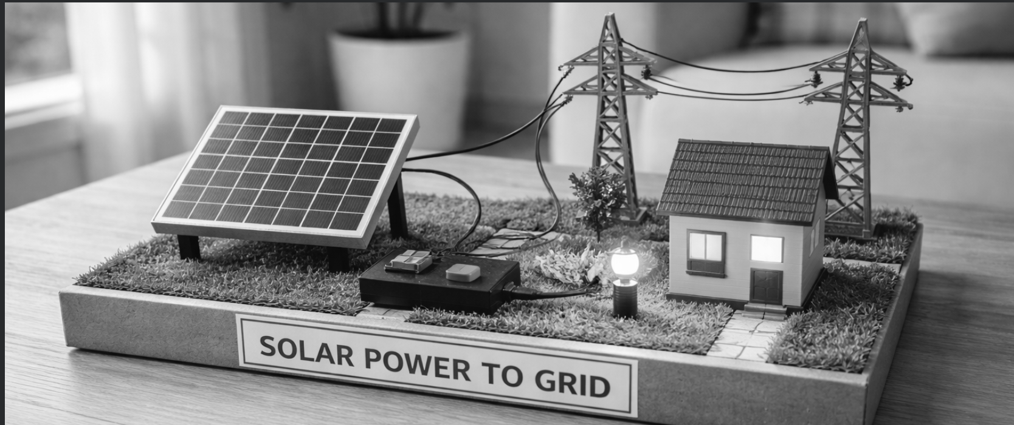
RESULT
Thus, the given color image was successfully converted into a grayscale image using Python and OpenCV.

